|  |  |  |  |  |  |
| --- | --- | --- | --- | --- | --- |
| Test Case ID | Objective of the Test | Steps | Test Data | What should happen | Result |
| Upload File | User should be able to upload any file provided there is room | 1. Click Upload 2. Attempt to upload different file types | 1. Uploading .pdf 2. Uploading .xlsx 3. Uploading .docx | The uploaded files should appear in the large open section of the media vault | The intended behaviour was achieved |
| Delete File | User should be able to delete any file within the media vault | 1. Have files already in the vault 2. Right click file or click the 3 vertical dots 3. Select delete | 1. Deleting .pdf 2. Deleting .xlsx 3. Deleting .docx | Once deleted the files should no longer be accessible in the media vault | The intended behaviour was achieved |
| Download File | User should be able to download the desired file from the media vault | 1. Have files already in the vault 2. Right click file or click the 3 vertical dots 3. Select download | 1. Downloading .docx 2. Downloading .png 3. Downloading .gif | The files should be downloaded into the users ‘Downloads’ folder | The document was successfully downloaded. The images were opened in an external window where they could then be downloaded from |
| Rename File | User should be able to rename desired files in the media vault | 1. Have files already in the vault 2. Right click file or click the 3 vertical dots 3. Select rename | 1. Renaming.docx 2. Renaming .png 3. Renaming .gif | The files should have their names changed to what the user specified in the media vault | The intended behaviour was achieved (Although multiple files could have the same name) |
| Categorize File | User should be able to add tags to files for categorization | 1. Have files already in the vault 2. Right click file or click the 3 vertical dots 3. Select Tag | 1. Tagging .dox 2. Tagging .png 3. Tagging .jpg | Files should receive tags which organises files with similar tags together | The intended behaviour was achieved |
| Search for a file | User should be able to search for desired files within the media vault based on file names, extensions or tags | 1. Have files already in the vault 2. Search for a file using name, extension or tag | 1. Multiple .jpg files 2. Different file types with same tag 3. Multiple .docx files with unique names | Based on the users search, only the files meeting the specified search parameters should be visible in the media vault | The intended behaviour was achieved |
| Confirmation of successful upload | Once a file has been uploaded, a prompt should appear as confirmation | 1. Click upload 2. Select a file for upload 3. Wait for the file to successfully upload | 1. Uploading .docx 2. Uploading .jpg 3. Uploding .png 4. Uploding .xlsx 5. Uploading .zip | Once a file is selected for upload, a progress bar of the upload should appear. Upon completion a prompt should confirm the upload | The intended behaviour was achieved. Along with the progress bar a percentage was added and a tick confirms the upload |
| Drag and Drop upload | A file can be uploaded by dragging a file from an external window into the upload section | 1. Click upload 2. Open an external window 3. Drag a file from window into the upload section | 1. Drag .jpg 2. Drag .docx 3. Drag .mp4 | The file from the external window should be uploaded in the usual manner after being dropped in the upload section | The intended behaviour was achieved. However the drop area is small and can be easily miss-clicked resulting in the file being opened in an external window (Appendix 2) |
| User storage quota | A set amount of storage is free for the user to utilize | 1. The media vault should be at capacity 2. Attempt to add an additional file | 1. Storage is at 50.62/50MB 2. Upload a 0.94 .jpg 3. Storage is at 49.68/50MB 4. Upload a 76.4 .mp4 | Once the quota is reached, no more files can be uploaded by the user until space is created | After the quota was exceeded no more files could be uploaded as intended (Appendix 1). However, large files which well exceed the data limit could be still uploaded even when the quota is almost reached. (Appendix 2) |
| Authentication | User can log in using Google Account credentials | 1. Log into the vault using Google account | 1. My personal MeiAckeele google account | The media vault will authenticate users based off their google account | The intended behaviour was achieved |
| View uploader information | The uploaders name is attached to the file they uploaded | 1. Upload various files 2. Check file information for uploaders name | 1. Upload .mp4 2. Upload .jpg 3. Upload .docx | For every file in the media vault the uploaders name should be attached. | Initially the uploaders name is attached to the file. However after the page is refreshed the uploaders name is no longer visible (Appendix 3) |
| View File Size | The size of each file in the vault is visible | 1. Upload various files of various sizes 2. Check file information for size | 1. Upload .mp4 2. Upload .jpg 3. Upload .docx 4. Upload .zip | The size of each file in the media vault should be visible for users | The intended behaviour was achieved |
| File preview | For certain file types such as images and videos, a thumbnail will appear | 1. Upload image and video files 2. Check if the files give previews | 1. Upload .jpg 2. Upload .png 3. Upload .gif 4. Upload .mp4 | A thumbnail providing a small image of the file should appear | The intended behaviour was achieved |

# Appendix

Shows images of cases which may not be explained in presentation

## Appendix 1

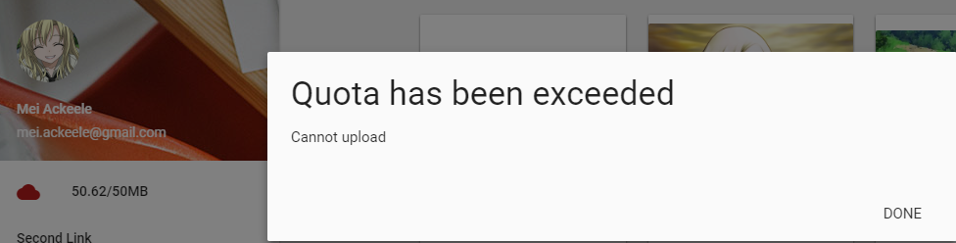

## Appendix 2



## Appendix 3

